**UNIVERSITY OF ENGINEERING AND**

**TECHNOLOGY LAHORE**



**Assignment # 3**

**Induction Motor Drive**

**Course Title: Control of Electric Machine Drives**

**Course Code: EE 535**

**Submitted to:**

**Dr. Syed Abdul Rahman Kashif**

**Assistant Professor**

**Submitted by:**

**Muhammad Shamaas**

**ID # 2018-MS-EE-4**

**Date of Submission: 2 January 2020**

**DEPARTMENT OF ELECTRICAL ENGINEERING**

**Induction Motor Model**

A simulation model of the indirect vector-controlled 5 HP, 200V, 0 Hz, 3 Phase induction motor (squirrel cage) drive will be presented. The design was based on the stator equations of the induction machine:

The rotor flux linkage was assumed to be constant:

For the vector controller, the flux is aligned with the d-axis hence

Substituting (5-) in the stator equations (1-2):

The flux producing d-axis component of stator current is constant in steady state:

The torque producing component of stator current is the q-axis component in synchronous frame:

Substituting (10), (12) and (13) in (8):

The stator angular speed is related to the rotor angular speed and slip angular speed by:

Substituting (15) in (14) leads to

Hence the simplified motor model is:

The electromagnetic Torque of the induction motor is given by

The motor dynamic equations are:

Representing (19) in terms of the electrical rotor speed:

The final transfer function between the electrical rotor speed and torque producing current component is:

Substituting (21) in (17):

The Simulink Model for the Induction Motor Drive and its simplification is presented in the figures below:

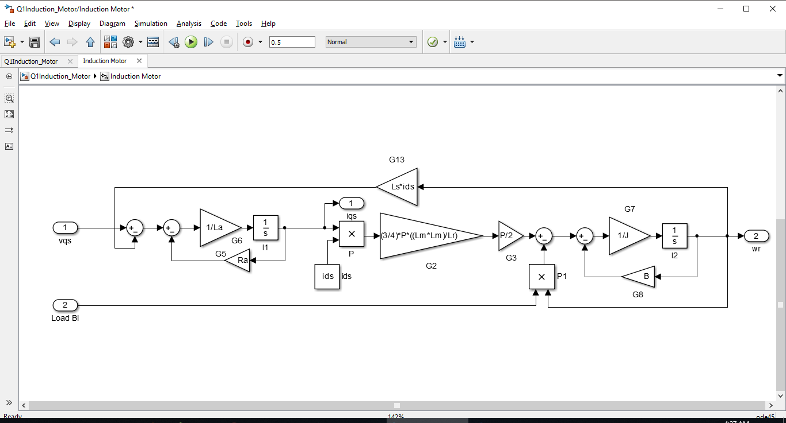

Figure 1: Induction Motor Model (Eq. 16 and 20)

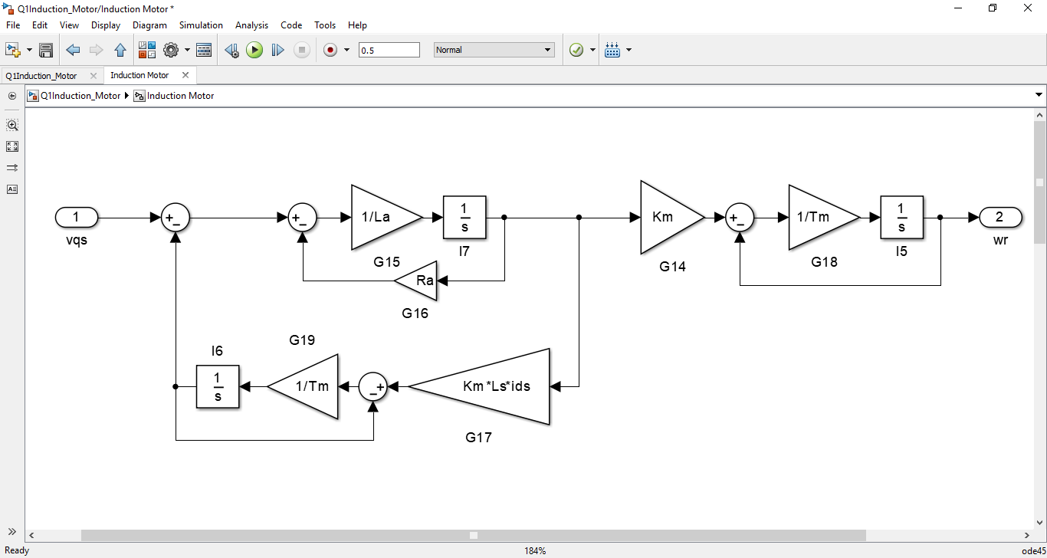

Figure 2: Induction Motor Model (Eq. 17 and 21)

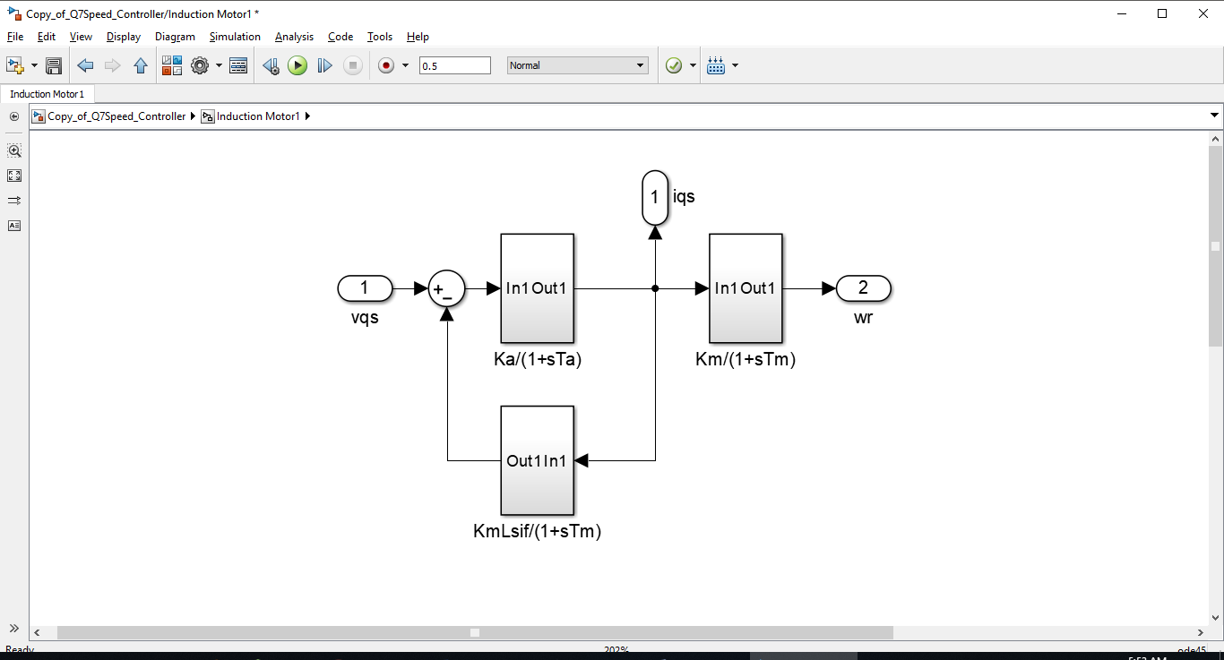

Figure 3: Induction Motor Model (Eq. 21 and 22)

SCIG Machine Constants

1. Rated Line-Line Voltage
2. Number of Poles
3. Rated Stator Frequency
4. Stator Winding Resistance
5. Rotor Winding Resistance
6. Stator Inductance
7. Rotor Inductance
8. Magnetizing Inductance
9. Moment of Inertia
10. Base Speed
11. Base Current
12. **Per unit Current and per unit Speed**

In order to test the model built in the last section, is applied at t = 0.1s. The Load Torque is applied at t = 0.3 s. The response is shown below.



Figure 4: Per unit current and speed

is a V step input applied at t = 0.1 s. Load Torque ( is applied at t = 0.3s.

Substituting in :

Hence,

The response represents two decaying exponentials and a step starting at t = 0.1s. Hence the simulation results are correct and thus a peak is seen in iqs when vqs is applied.

Hence, consists of a step function starting at t = 0.1 s and two decaying exponentials starting at t = 0.1 s. These results also match with the simulation results.

1. **Steady State per unit Current and per unit Speed**

In this section, the steady state values of current and speed are analyzed.



Figure 5: Steady state current and speed

Steady State Values

In steady state,

The calculations are close to the steady state simulation results in Figure 5.

1. **Limiting Rising Rate of Voltage**

A rising rate limiter is added between the voltage source and motor. The current and speed response is given below.



Figure 6: Per unit current and speed

Effect of Rate Limiter

is a V / 0.1 s ramp starting at t = 0.1 s and ending at t = 0.2 s.

Hence,

Hence

Which represents a pulse starting at t = 0.1 s and ending at t = 0.2 s, and a ramp starting at t = 0.1 s and ending at t = 0.2 s. The current also has four decaying exponentials starting at t = 0.1s or t=0.2s. It can be verified using this equation that iqs(t) = 0 A (0 p.u.) at t = 0.1 s. This matches with the simulation result.

Since,

Hence, consists of a ramp function starting at t = 0.1 s and ending at t = 0.2 s and a step function starting at t = 0.1 s and ending at t = 0.2 s. It also has four decaying exponentials starting at t = 0.1 s or t=0.2 s. These results also match with the simulation results.

**DC-DC Converter and Unipolar PWM**

1. **Testing the Model**

In this simulation, vqs is supplied using PWM technique. The Average value of is equal to the reference. This is achieved by changing the duty cycles dA and dB. The dc voltage for unipolar PWM is 285 V.

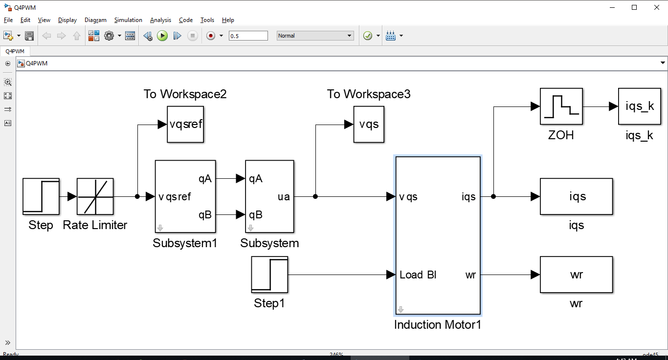

Figure 7: Voltage Control based Model



Figure 8: Per unit current and speed

The results of current and speed are almost the same as the last section, where an ideal voltage source was used. The current has much more ripple around the mean value as compared to the last case. This is because the current graph has a much thicker line during transition periods. This is when unipolar PWM is adjusting the duty cycles to reach steady state current. The adjustments cause current to oscillate around the mean value. The Moment of Inertia is quite high hence the speed is unaffected by current oscillations. The speed graph is almost like the earlier case.

1. **Plotting Armature Voltage and Current**

In this section, the resulting current and supply voltage waveforms are analyzed.



Figure 9: Steady state current and speed

The Stator current iqs (blue) is a triangular wave because La charges up (current rises) when converter output vqs is high; and La discharges (current deceases) when PWM signal becomes zero. The vqs on/off sequence is such that the current rises and drops by equal amounts in steady state. Hence the sampled average current iqs_k (red) seems constant.

1. **Current Controller**

Instead of using the unipolar PWM, the current iT was controlled using current feedback loop. The feedback gain was:

After comparing the feedback with the reference, the error was passed through an Inverter. The Inverter was modeled as a gain with a time lag.

The overall transfer function from to iT is:

It can be approximated as

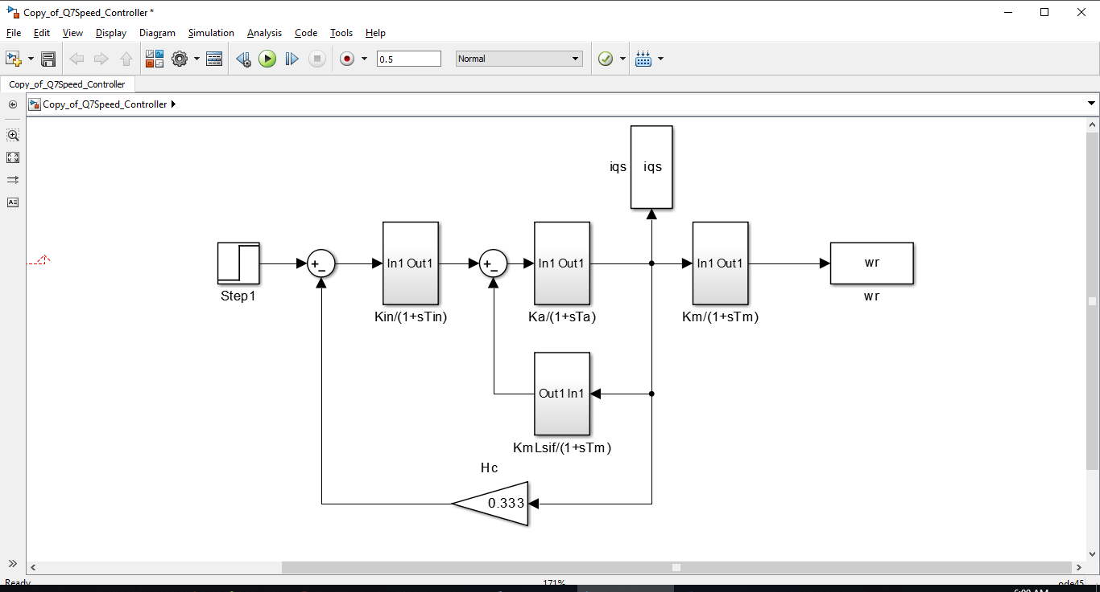

Figure 10: Current Control Loop Model



Figure 11: Current and Speed Response

For Torque control, a Torque square wave reference is provided. Using (18):

and the Current Control Model for , the torque control model is developed as shown in Figure 12.

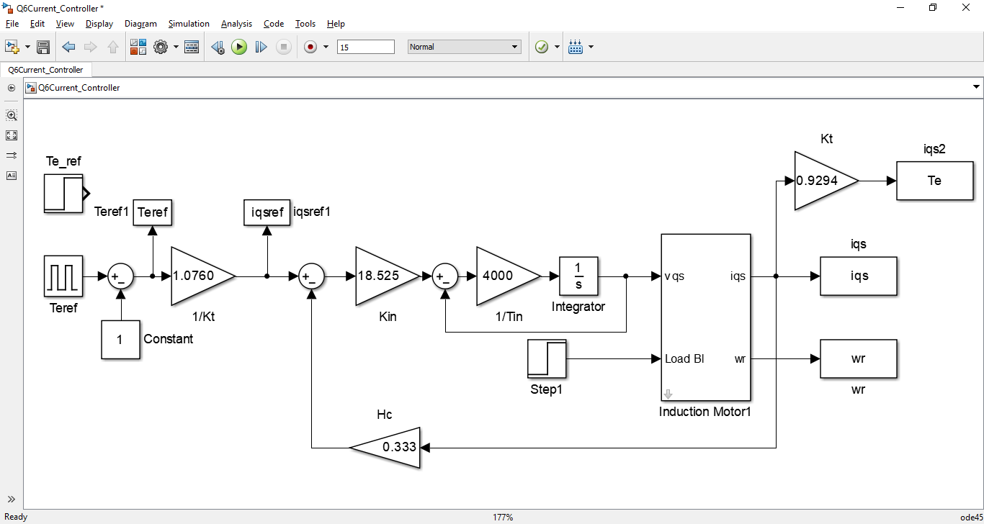

Figure 12: Torque Control Model



Figure 13: Torque Step Response

From the torque step response (Fig. 13), the rise time (from TM = 0.1Nm to TM = 0.9 Nm) is 0.2537 s.

The Time Constant of Torque is . The rise time is 0.0016 s.

1. **Speed Controller**

The speed control feedback loop generates the reference for torque producing current component to drive the current control feedback loop. The rotor electrical speed is sensed and passed through a filter:

The output of the filter is compared with the reference speed. A PI controller generates the current control loop reference:

The complete Speed Control Model and its simplification is shown in Figures 14-16.

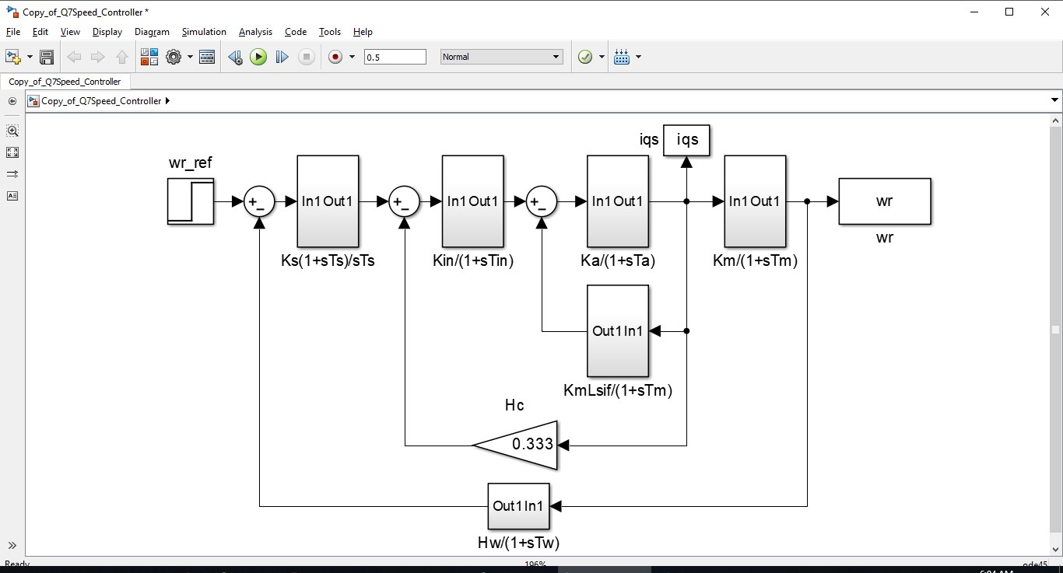

Figure 14: Speed Control Model

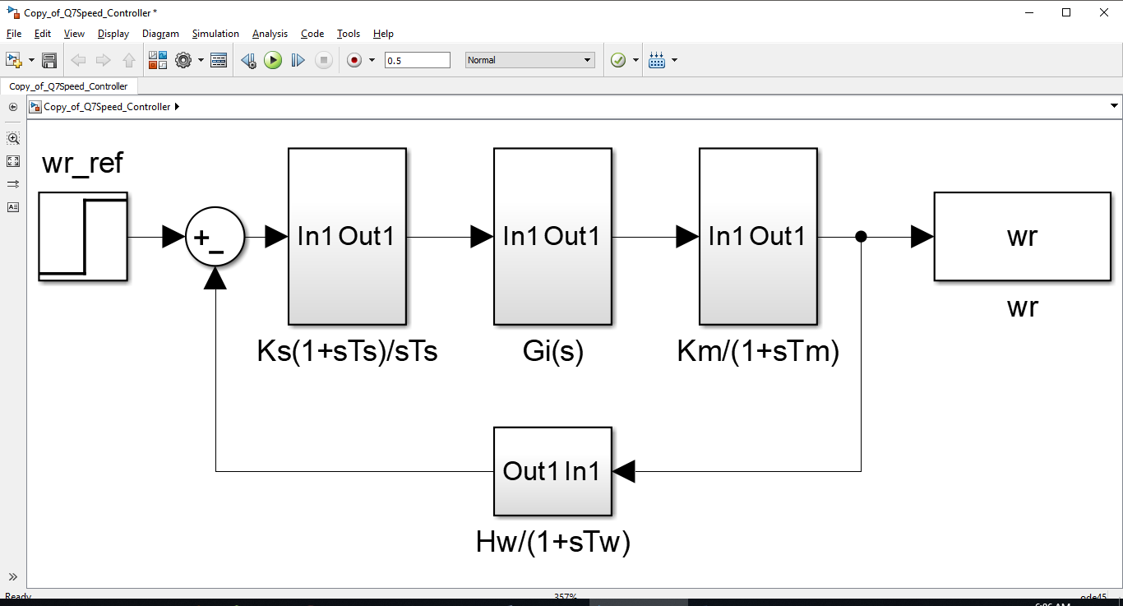

Figure 15: Simplified Speed Control Model

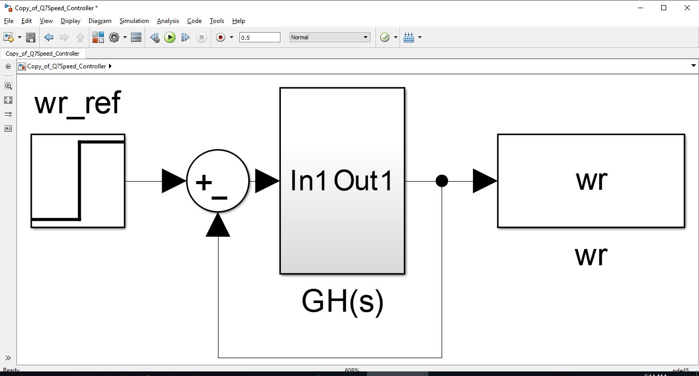

Figure 16: Simplified Speed Control Model

The Speed Control Transfer function is:

1. **Testing the Model**

GH(s) can be approximated using a symmetric optimum function with damping ratio 0.707:

This results in

The results of the implemented speed controller are shown below.



Figure 17: Speed and Current Response



Figure 18: Speed Step Response

From the simulation results, the rise time (from 0.1 to 0.9 rad/s) is 0.1506 s.

1. **Tolerances**

The PI controller parameters were designed for the original values of Rs and Ls. The controllers provided desired closed loop bandwidth using perfect pole-zero cancellation. With temperature changes, Rs increased to 1.5 Rs. Moreover, magnetic saturation decreased Ls to 0.7 Ls. The resulting response is shown below.



Figure 19: Speed and Current Response

The Speed and Current responses are not the same as before. The current and speed rise vary fast and are unable to track their respective references. This indicates that the controller is not robust against parameter variation. The PI speed and current controllers have been affected a lot by the parameter errors. Due to imperfect pole-zero cancellation, the controllers are unable to generate precise control commands to track speed and current references.

**Conclusion**

The electromechanical equations of squirrel cage Induction motor were used to build a Simulink Model. The discrete time solver was able to generate accurate values for per unit current and per unit speed. The results were verified using steady state analysis of the Induction Motor. The transient behavior of the Motor was verified using the Laplace transform of characteristic equations. Time domain response obtained using inverse Laplace transform matched with the simulation results. Hence the accuracy of the results was confirmed by mathematical results; in the case of voltage step and Load Torque step application. The response was dictated by machine constants like Resistance, Inductance and Moment of Inertia.

The rate limiter caused a voltage ramp to appear at the Motor input. When it was modeled in Laplace domain, the transient response of this input also matched accurately with the simulation results.

Next, the motor was fed from a four-quadrant DC-DC converter, whose DC-bus voltage was 285 V. The Unipolar PWM generated a Square wave voltage whose average value was controlled using its Duty Cycle. Hence the complete range of voltages from 0V to 285V could be supplied to the motor. The results of current and speed were almost the same as the last experiment, where an ideal voltage source was used. Unipolar PWM duty cycle adjustments cause current to oscillate around the mean value. The Moment of Inertia was quite high hence the speed was unaffected by current oscillations.

An inverter was used to generate voltage reference from given Torque/ Current reference. Its output then drove the Motor. The current controller parameters were adjusted to get desired bandwidth. The Proportional and Integral gains were set to cause pole-zero cancellation.

The Speed Controller contained a feedback loop to track speed reference. A low pass filter was used to sense the electrical rotor speed. The error was passed through a PI controller to generate the reference for the cascaded current controller. Block reduction was used in determining the overall transfer function. After the simplification, the outer loop was solved for Proportional and Integral gains. The desired speed response was checked using measurement of rise time.

With temperature changes, Motor parameters changed. As a result, the Speed, current and Torque responses degraded drastically. This indicated that the controllers were not robust against parameter variations. Imperfect pole-zero cancellation made the response unsatisfactory.